**Event Management ( Event Master)**

***Event Master*** is looking for an event management software that will help them manage their events effectively along with the attends & location information. As a developer. Here is the complete

information of the project. Entities(Objects) Involved **Location ( Address Book )**

1. Street ( Text )
2. City ( Text )
3. State ( Text )
4. Postal Code ( Text )
5. Country ( PickList )
6. Landmark ( Text )
7. Veriﬁed ( checkbox )

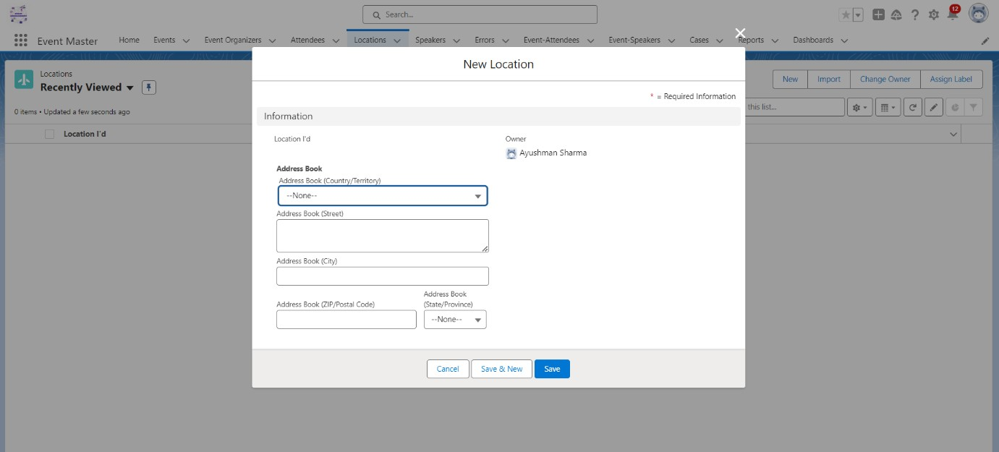

**Event Organizer**

1. Name ( Standard ﬁeld )
2. Email ( Email )
3. Alternative Email ( Email )
4. Phone ( Phone )
5. Alternative Phone ( Phone )
6. Address ( Lookup - Location )

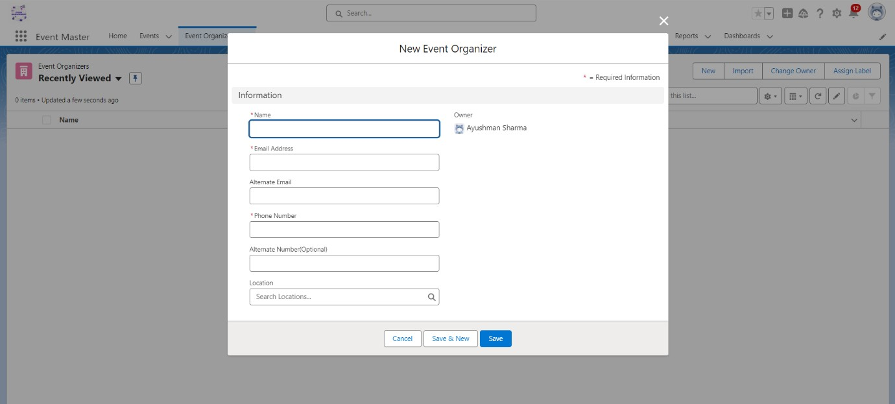

**Event**

1. Event ( Standard Auto Number )
2. Name ( Text )
3. Status ( Created, Published, In Progress, Completed, Post Poned, Cancelled ) - Picklist
4. Organizer ( Lookup - Event Organizer )
5. Start Date/TimeEnd Date/Time
6. Max Seats ( Number )
7. People Attending ( Rollup Summary Field )
8. Remaining Seats ( Formula ﬁeld - “Max Seats - # People Attending“ )Lookup ( Location )
9. Location Veriﬁed ( **Formula Location** **r.Veriﬁed** **c** )
10. Live? ( Checkbox )
11. Recurring? ( Checkbox )
12. Event Type ( In-Person, Virtual ) - Picklist
13. Frequency ( Daily, Weekly ) – Picklist

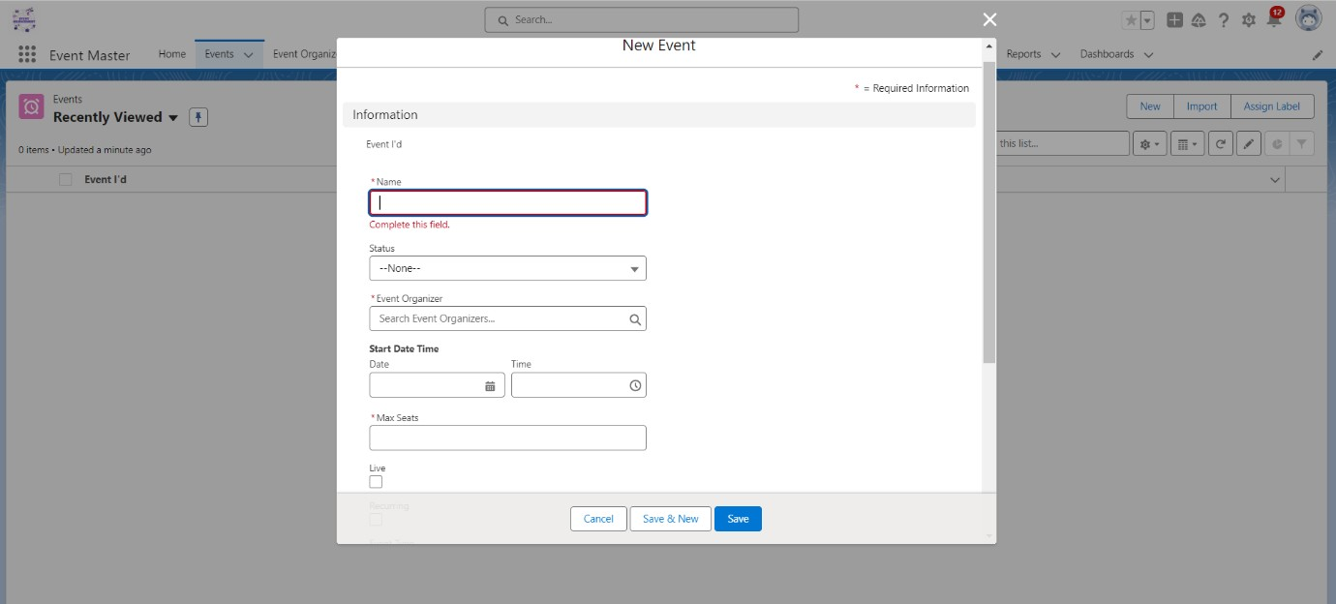

**Attendee**

1. Name ( Standard )
2. Email ( Email )
3. Phone ( Phone )
4. Company Name ( Text )
5. Address ( Lookup - Location )

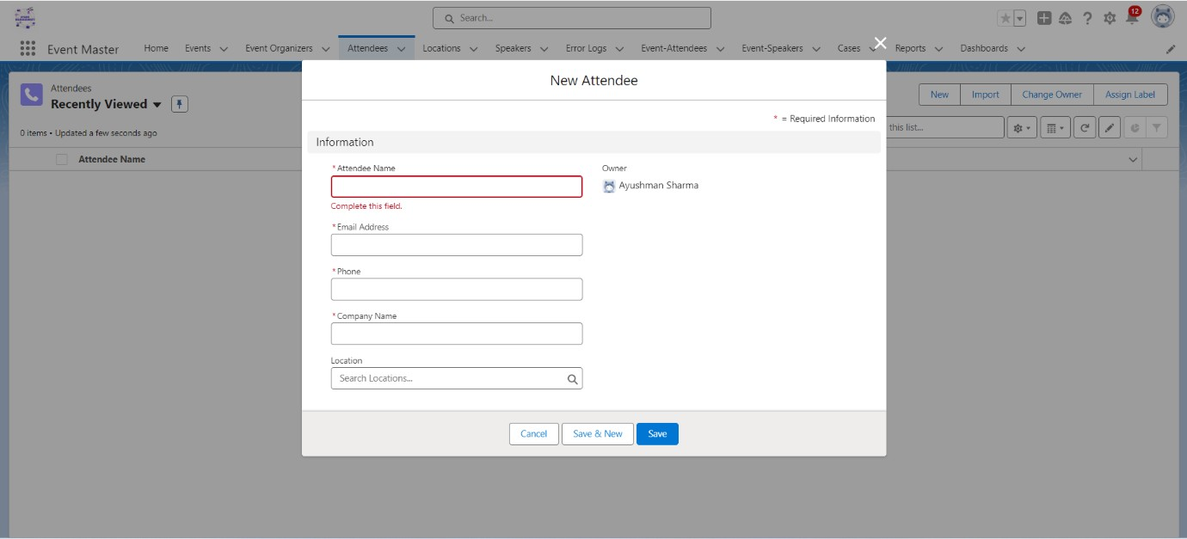

**Speaker**

1. Name ( Standard Name Field )
2. Email ( Email )
3. Phone ( Phone )
4. Company ( Text )

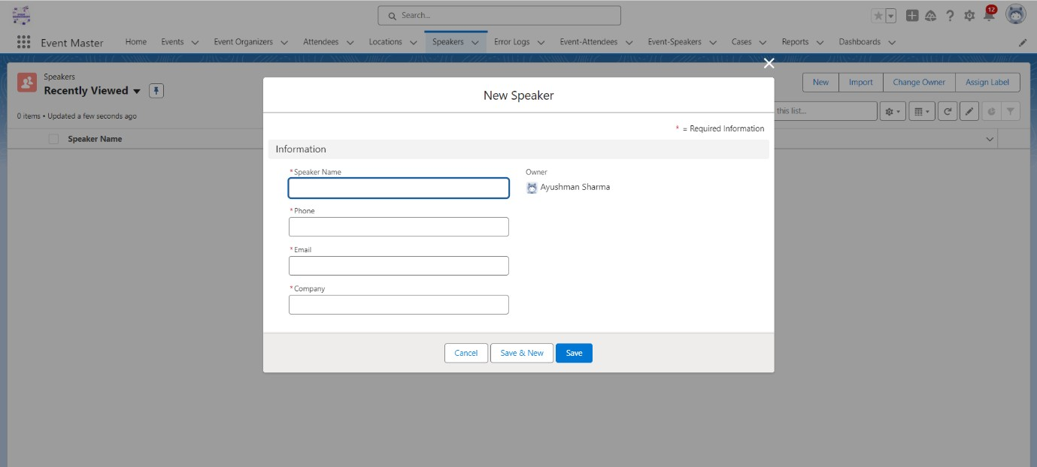

**Event-Attendee**

1. Event ( M-D Event )
2. Attendee ( M-D Attendee )

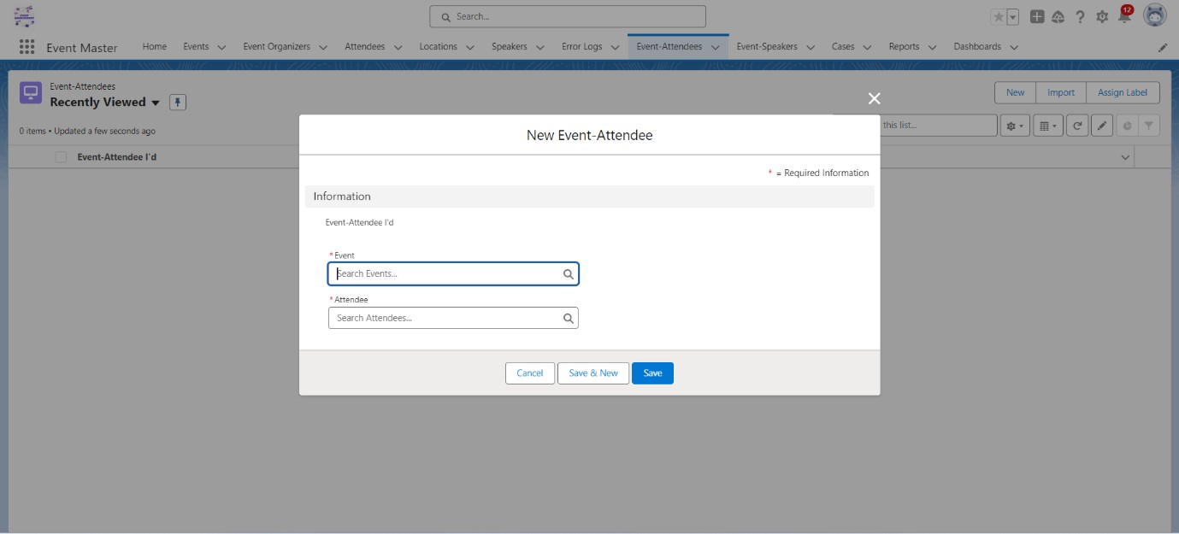

**Event-Speaker**

1. Event ( M-D Event )
2. Speaker( M-D Speaker )

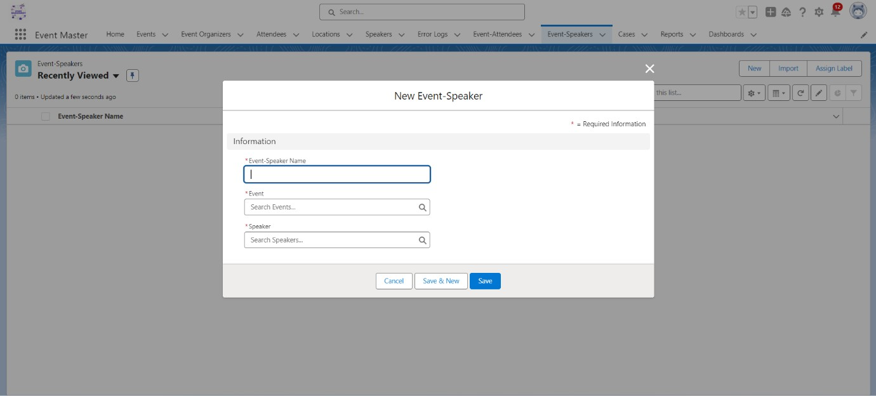

**Error Log**

1. Log Date/Tile ( Store the Date & Time details when the Error Occurred )
2. Log Details ( Stores the Complete Stack Track about the Problem ) - Text Area Long
3. Process Name ( The Name of Either Apex Class or Apex Trigger ) - Text
4. Log # ( Auto Generated Number )

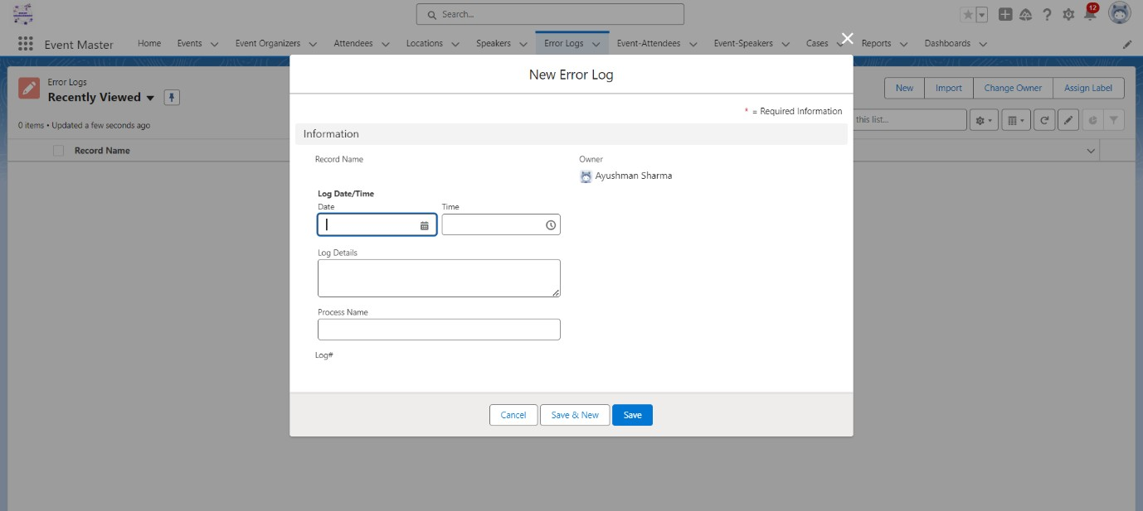

***Total 15 milestone has been decided which as follows***

# Milestone 1 ( Object Setup )

1. Complete the Object Structure, Choose the correct Data Type for each ﬁeld.
2. Create a Lightning Application & name it “***Event Master***” .



Here is the **Entity Relationship Diagram**

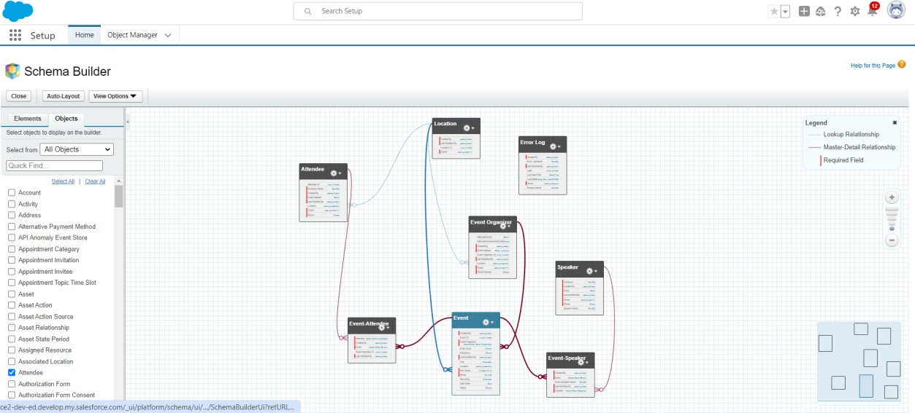

## Milestone 1.1 - Validation Rule Setup 1 - Validation Rule on Event Object

* 1. - If Recurring? checkbox is checked then user must need to ﬁll Frequency ﬁeld & If checkbox is unchecked then User can not select Frequency ﬁeld.
  2. - If Virtual is Selected as Value for Event Type ﬁeld then Prevent User to Select Location on Event Record.
  3. - End Date/Time must be at-least 1 day ahead of Start Date/Time ( If there is a value in End Date/Time ﬁeld )
  4. - If Event Type ﬁeld value is In-Person then user must need to select Location on Event Record.

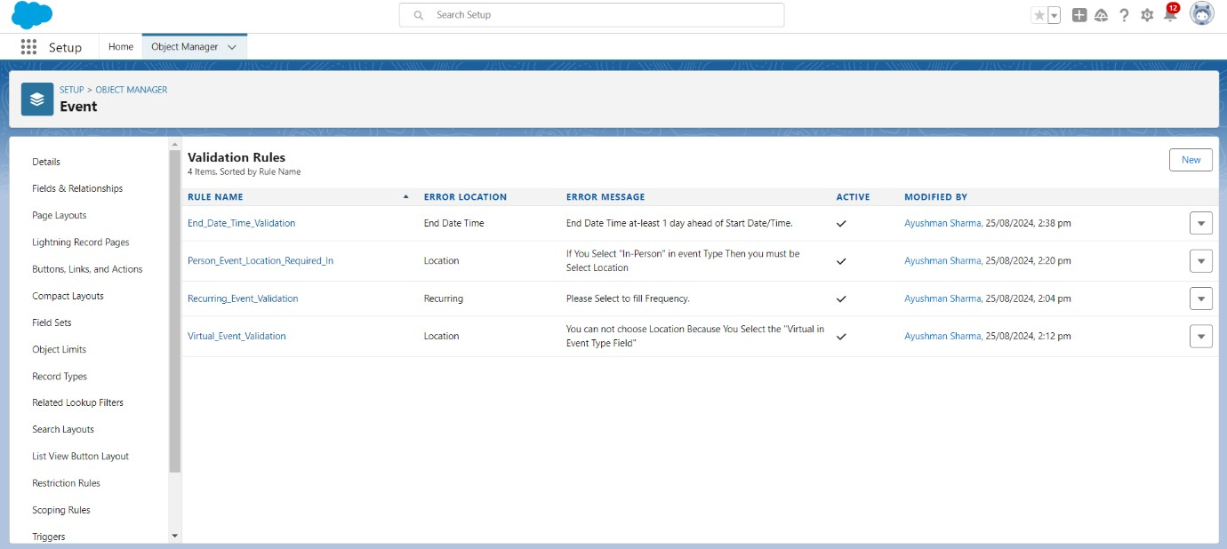

## - Event Attendee Object

* 1. - Attendee can only be associated with the Event whose End Date is in future & Event Live Checkbox is checked and Event is accepting the Attendees ( means Remaining Seats ﬁeld value is not 0 )

## - Event Speaker Object

* 1. - Speaker can only be associated with the Event whose End Date is in future & Event Live Checkbox is checked

## Milestone 1.2 - Duplicate Rule Setup (with the help of trigger) 1 Speaker Object

* 1. 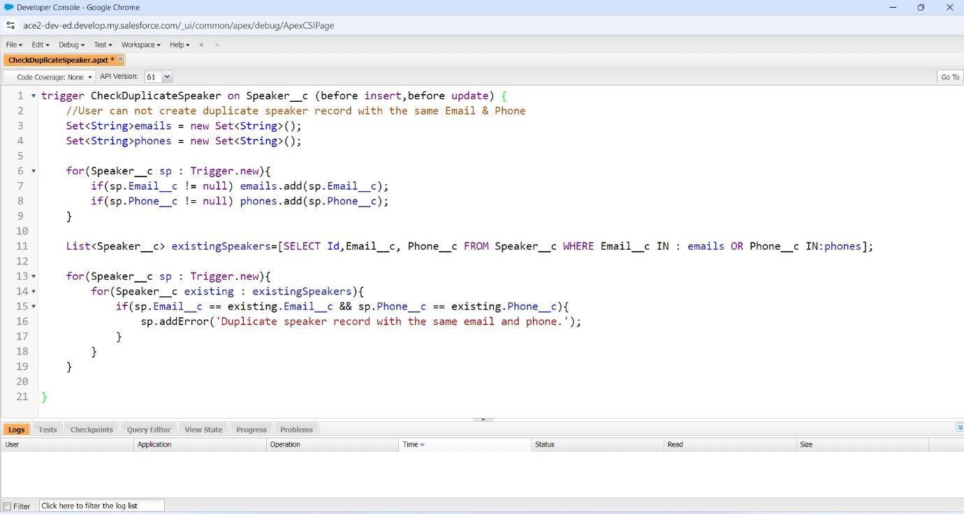- User can not create duplicate speaker record with the same Email & Phone

## Attendee Object

2.2 - User can not Create duplicate attendee with the Same Name, Email & Phone

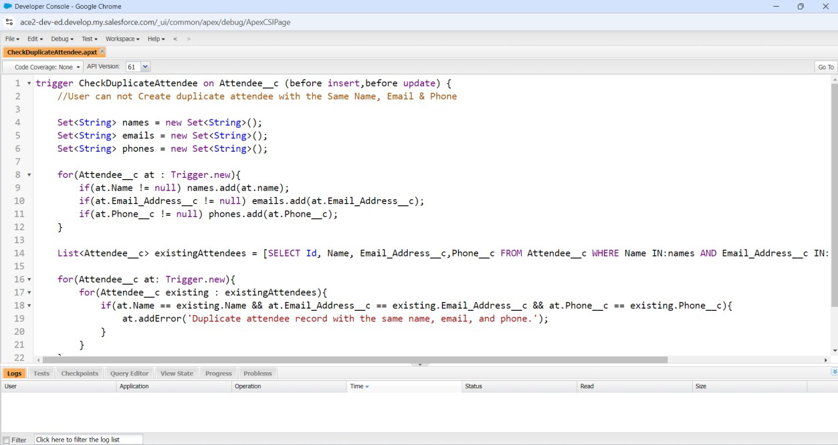

## Event Organizer Object

* 1. - Apply the same rule as Speaker object for not to having duplicate Organizer in the System

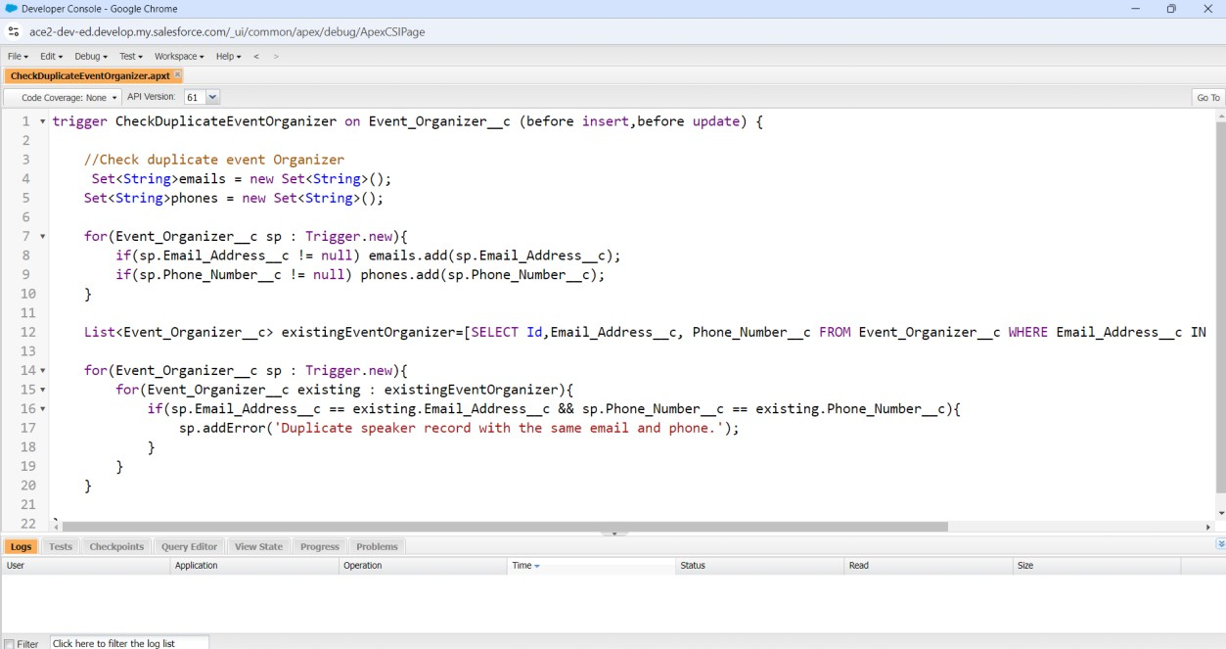

## Milestone 1.3

**Pre-Requisite:**

* + 1. ( Organization Level Security )
    2. ( Object Level Access )
    3. ( Record Level Access )
    4. ( Field Level Access )

## Proﬁle, User, OWD & Role Setup

1. ***- Proﬁle Setup -***
   1. Create 3 Proﬁles ( Clone from Standard User ), the name of the proﬁle will be Event Organizer

,Event Attendee & Speaker.

* 1. ***- User Setup -***
     1. **-** Create users for the testing purpose

## - Role Setup -

* 1. **-** Create Roles ( Organizer & Attendee & Speaker ). All roles must report to CEO
     1. **-** Role Hierarchy
* CEO
* Organizer
* Attendee
* Speaker

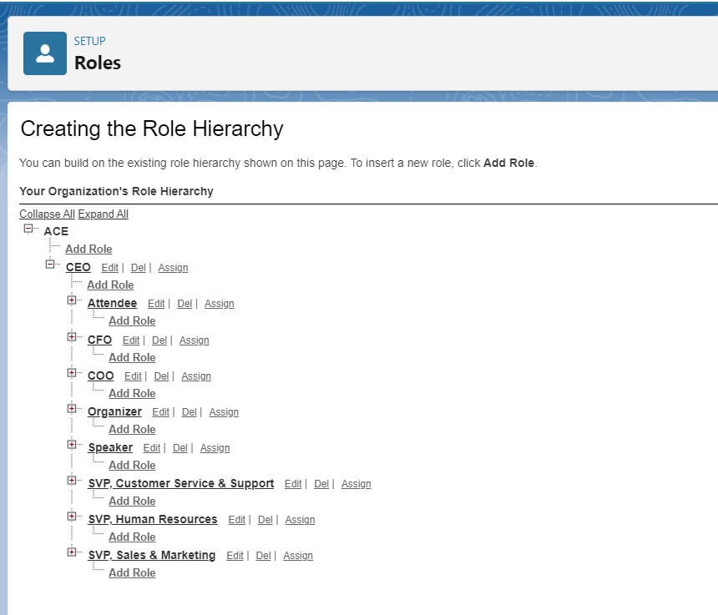

* 1. ***- OWD Setup -***

***1.3.3.1 -*** Check the table for OWD below and make the changes

***Object Permission Set-up :- Please provide the objects & ﬁelds level permission at the Proﬁle level as per the table below.***

|  |  |  |  |
| --- | --- | --- | --- |
|  | Proﬁle |  |  |
| Object Name | ***Event Manager*** | Speaker | ***Attendee*** |
| ***Event*** | CRED | R | R |
| ***Event - Organizer*** | CRE | R | R |
| ***Speaker*** | CRE | CRED | R |

|  |  |  |  |
| --- | --- | --- | --- |
| ***Attendee*** | R | X | CRE |
| ***Location*** | CRED | R | RCE |
| ***Event - Speaker*** | CRED | RCE | R |
| ***Event - Attendees*** | CRED | X | RC |
|  |  |  |  |
|  | | | |

***Note: -***

***C - Created R - Read***

***E - Edit***

***D - Delete***

**X - *No Access***

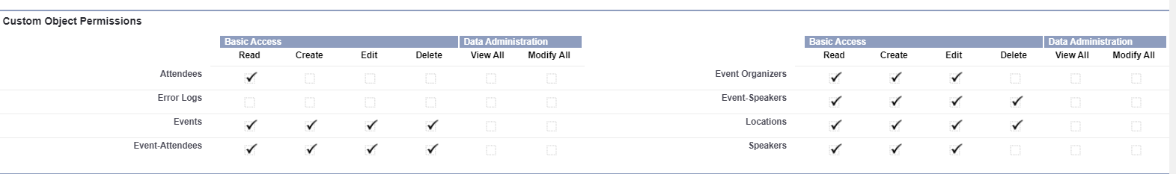

**(OWD) *Organization Wide Default : -***

|  |  |
| --- | --- |
|  |  |
| Object Name | ***Organization Wide Default*** |
| ***Event*** | Public Read Only |
| ***Event - Organizer*** | Public Read Only |
| ***Speaker*** | Private & Create a Sharing Rule to share the Speakers with Organizers ( Role ) |
| ***Attendee*** | Private & Create a Sharing Rule to share the Attendee with Organizers ( Role ) |
| ***Location*** | Public Read Only |
| ***Event - Speaker*** | Public Read Only |

|  |  |
| --- | --- |
| ***Event - Attendees*** | Public Read Only |
|  | |

**Sharing Rule Setup:-** As per the business requirement, we need to share every Speaker & Attendee record with Organizer Role. For this, you need to setup 2 Sharing Rules as per the below details.

**Speaker Object -** Create a Sharing Rule which will share the Speaker records with the Role Organizer. And the permission should be Read/Edit.

**Attendee Object -** Create a Sharing Rule which will share the Attendee records with the Role Organizer. And the permission should be Read/Edit.

**Milestone 2 -**

**Apex Class Development: -** Develop a reusable Apex Class which contains a method to insert the Error log Object records. This method must contains the parameters to get the dynamic details of the ﬁelds ( Log Date/Tile, Log Details & Process Name )

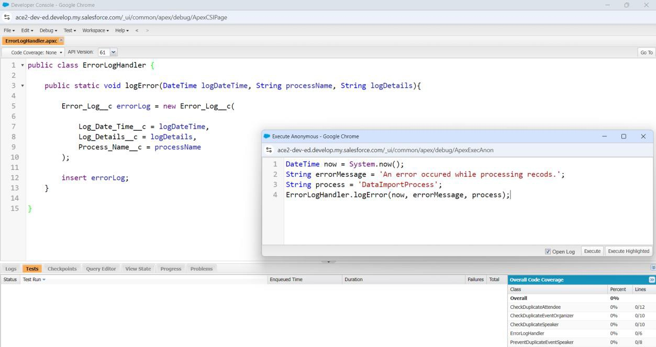

# Milestone 3

**Trigger Development ( Event - Speaker Object ) -** Develop a Trigger on Event - Speaker object which will throw an error if the Speaker Selected on Event - Speaker Record already have an Event against his name. i.e - For a Speaker there will be only one event at a time. Reject Duplicate Bookings

Q1 In which object the Trigger will be ( Event - Speaker ) Q2 What are the events ( before insert , before update )

Output - Check the duplicate bookings and throw the error

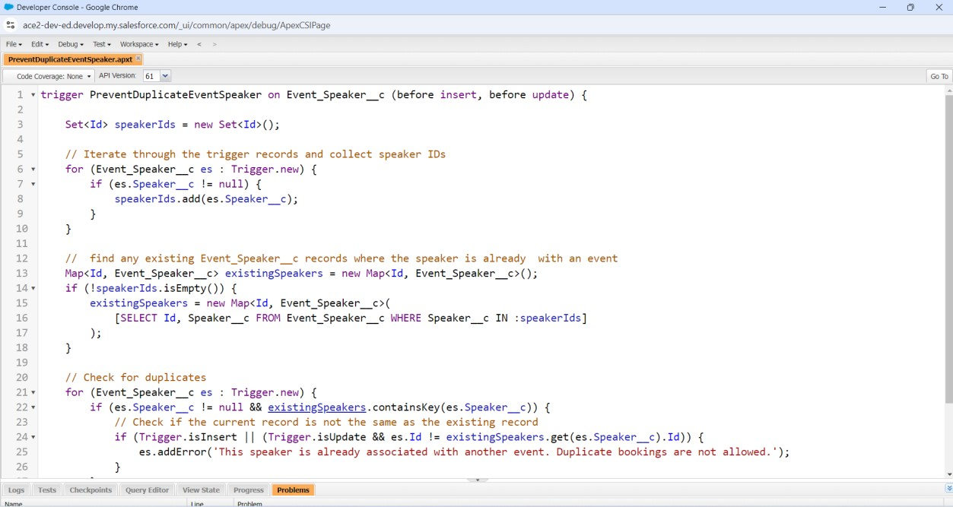

# Milestone 4 -

**Trigger Development -** Develop an Apex Trigger on **Event Attendee Object ( Whenever a New Record gets created )** to send the email to Attendee saying that registration has been

conﬁrmed . In the email include the basic details of attendee like name, email, phone. Also, send an email to attendee. Use below format for email

**Subject -** Pass for the “ Event name Here”

**Email Body -** Dear Attendee Name,

Thank you for registering for “ Event Name Here” which will be Organized on “ Event Date Here ” & will be held in “Event Location Here”. We are excited to have you, see you in the event.

Find the Google Map Location for the Event Here. ([https:/ www.google.com/maps/place/](https://www.google.com/maps/place/)) + Add your Location Here Thanks,

“Organizer Name Here”

**Must Have -** Bulk record handling along with the Exception handling. Use of Handler/Helper Class

**APEX CLASS**

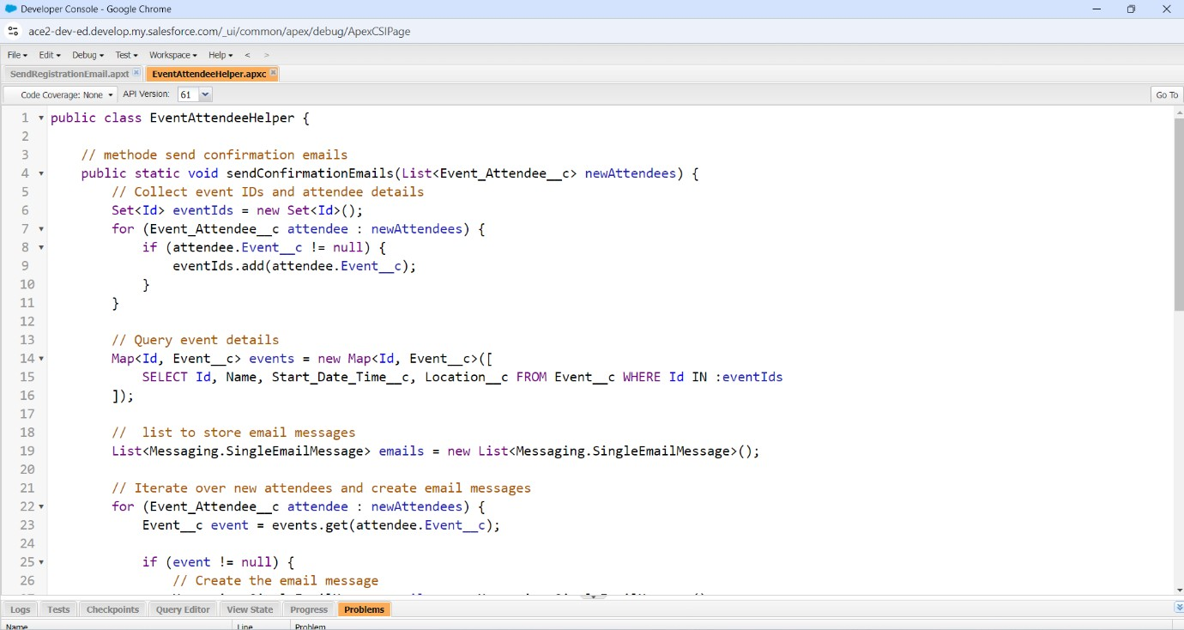

**TRIGGER**

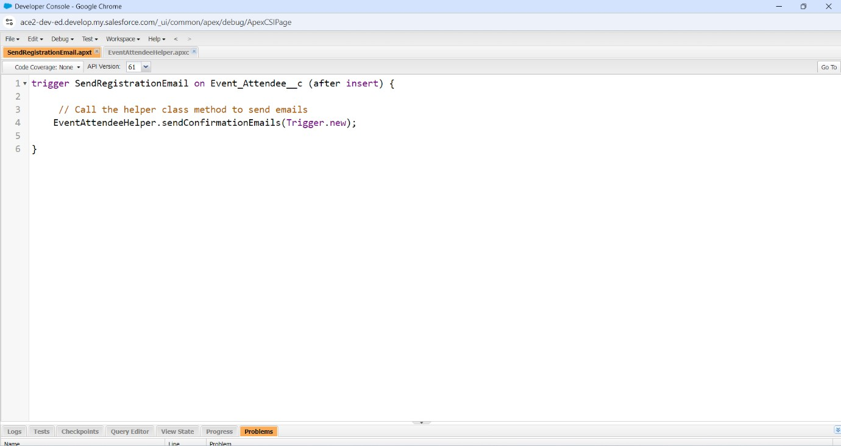

# MileStone 5

1. Setup VS Code for Non-Scratch Org into your Machine and Connect with Salesforce.
2. Retrieve the Salesforce Metadata From Salesforce to VS Code
3. Deploy code to VS code.

Develop a Lightning Web Component which will display the Form Input for the Event to take the input from the user and save the Event Record. The Input Form should contain the below ﬁelds from Event object.

1. Name ( Custom Field )
2. Organizer ( Lookup )
3. Start Date
4. End Date
5. Max Attendees
6. ***Event Detail RichText ﬁeld***
   1. We will be using Lightning ui record API to create the record that means no Apex Class is required.
   2. 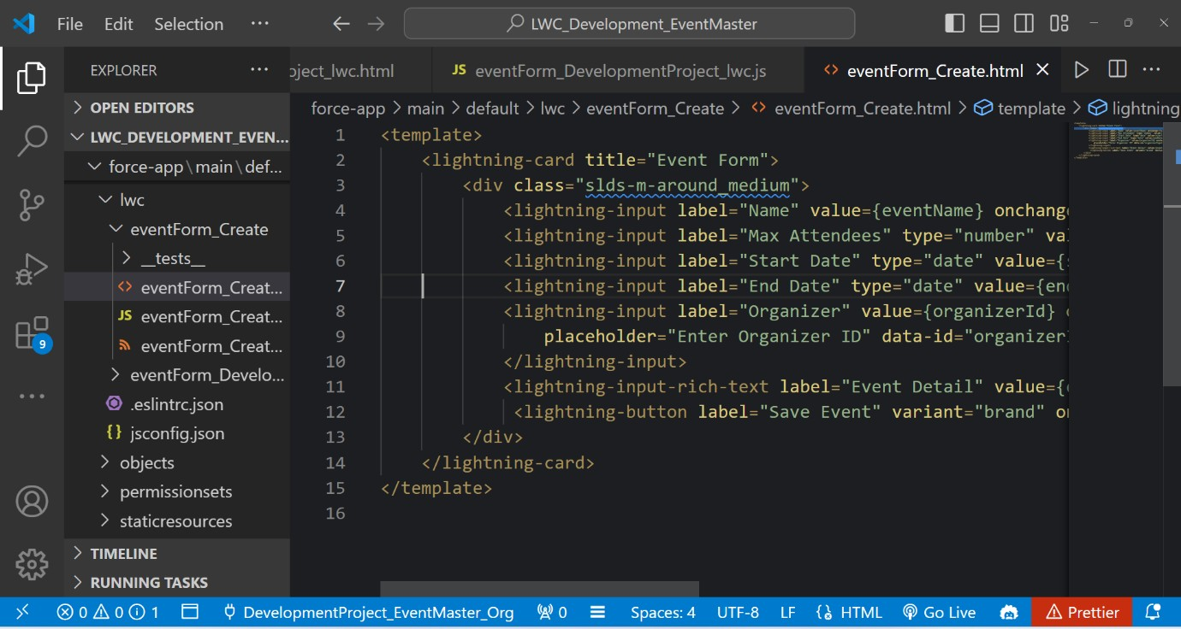After Creating the Record, user should be redirect to event detail page.

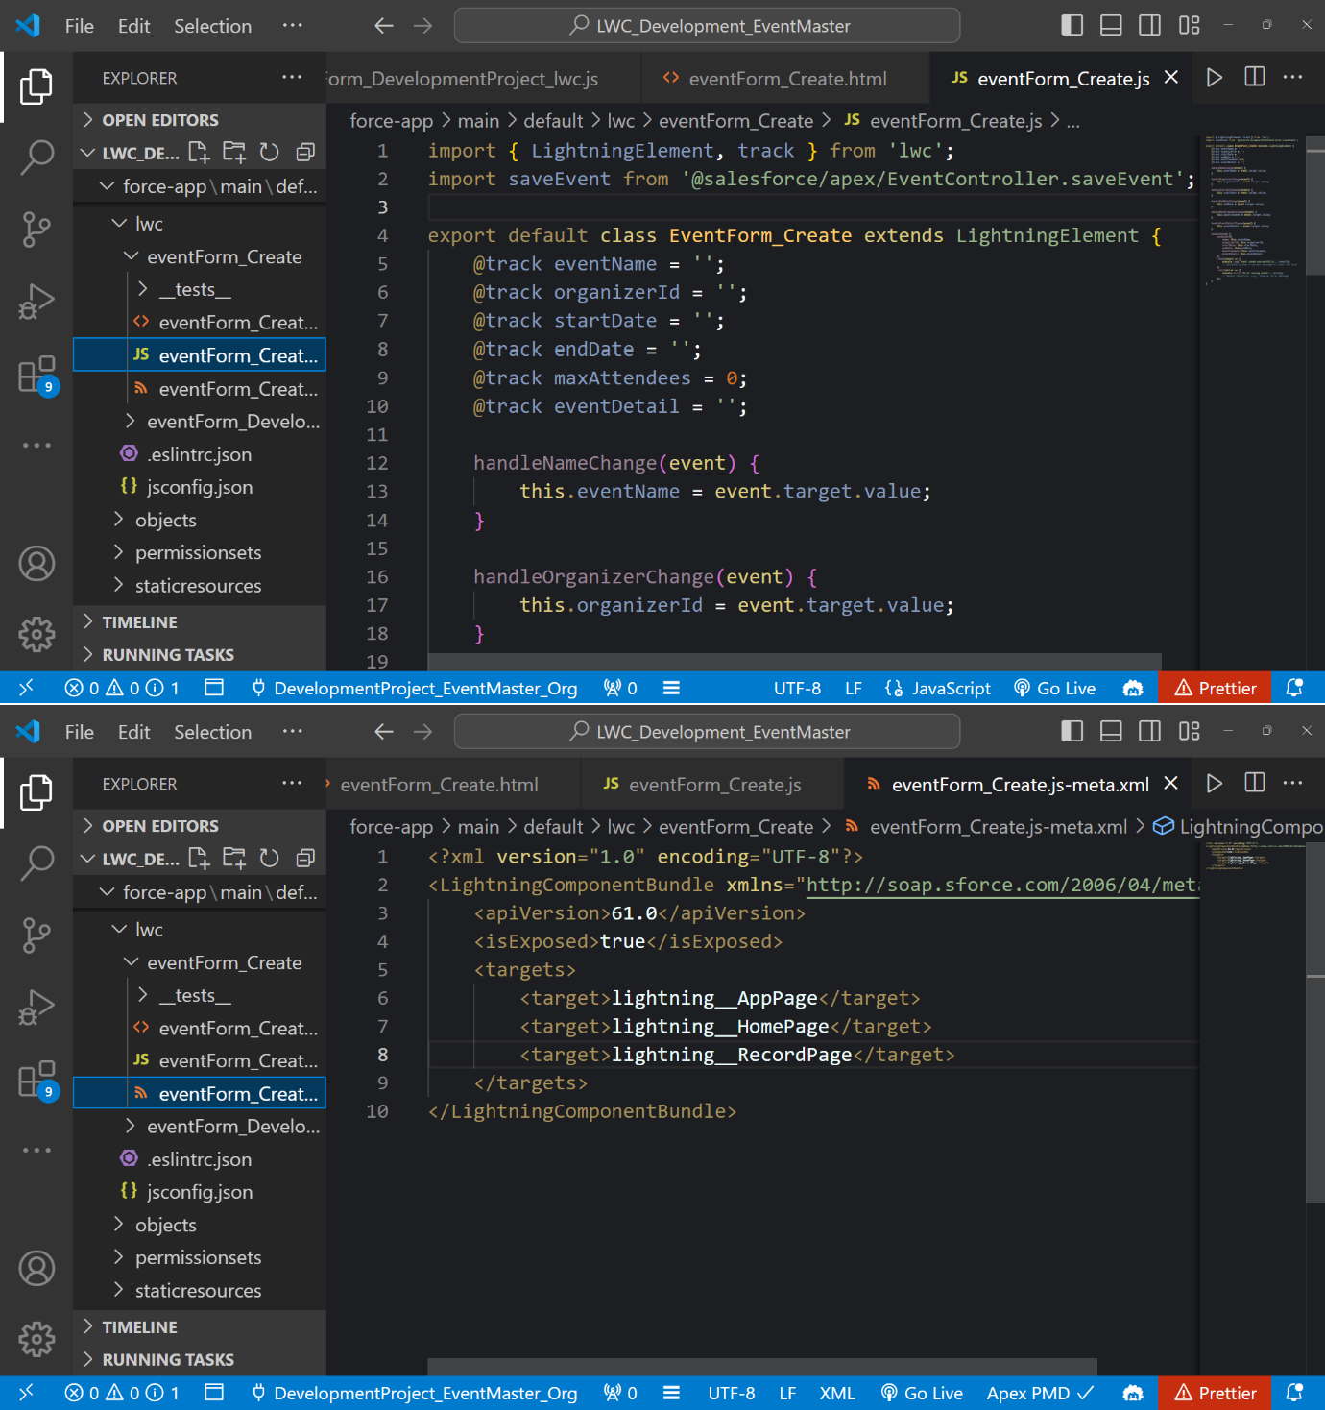

**OUTPUT**

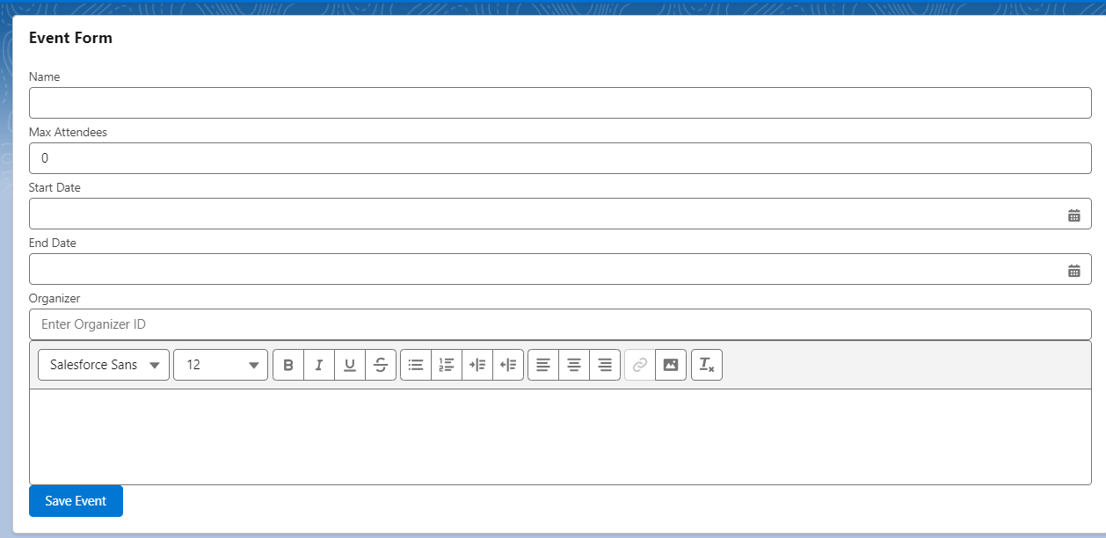

# MileStone 6

**Event Detail Component: -** Develop a Lightning Web component to display the event details. This Component will contains some additional details like Speaker Details, Location Details & All Attendees who are attending the Event. So basically this component will have multiple tabs like below. Clicking on Each Tab it should open the detail related to Event.

## Note: - This component will be used to display the Event Details.

|  |  |  |  |
| --- | --- | --- | --- |
| Event Details | Speaker Details | Location Details | Attendees Details |
|  |  |  |  |

**Part 1 -**

* + 1. - Event Details - LDS ( Lightning Data Services )
    2. - Speakers - Data-table

## Part 2 -

* + 1. - Location Details
    2. - Attendees Details

' '\. \ '\ **l** \ -- ... _ *: �* 1 .._., ***,1***,,,,,.---- --.......,_, ' '\. \ '\ **l** '\. -- ... _ *:* "-

•

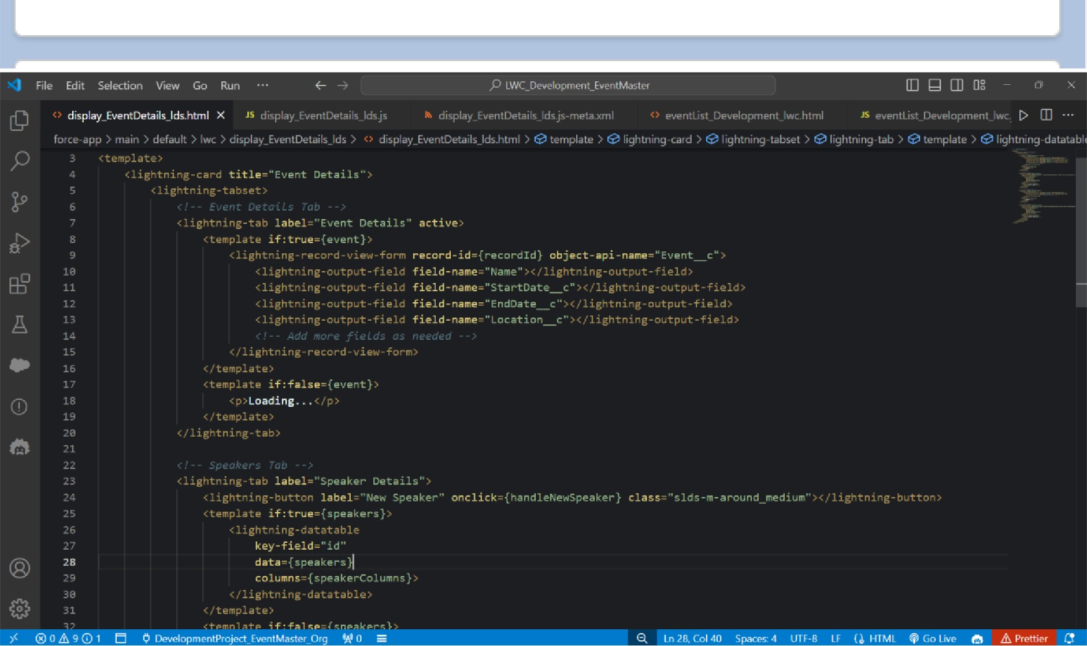

**Event Details**

**Event Details** Speaker Details location Details

Attendees Details

Event I'd

Event-0001

location

Series-24000

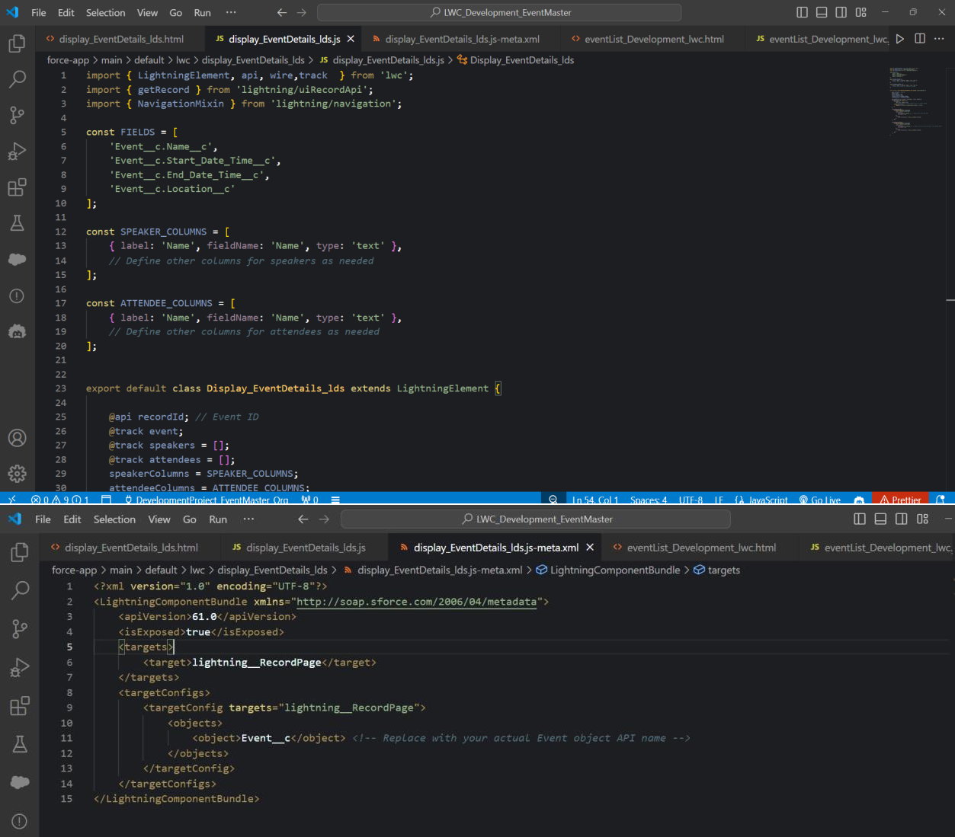

# Milestone 7

**Develop Event List Component: -** Develop a Lightning Web Component which display all the events in a DataTable which are Live and on clicking on Event Name page it should redirect to Event Detail Page. Event that are displayed in data-table that StartDate of the event record should be either equals to today or greater.

## Must Have: - Search Functionality to search the event based on the name.

We will implement this component in 2 part and details are as below. **Part 1 -**

Develop the component and Display the record in the data-table **Part 2 -** Implement

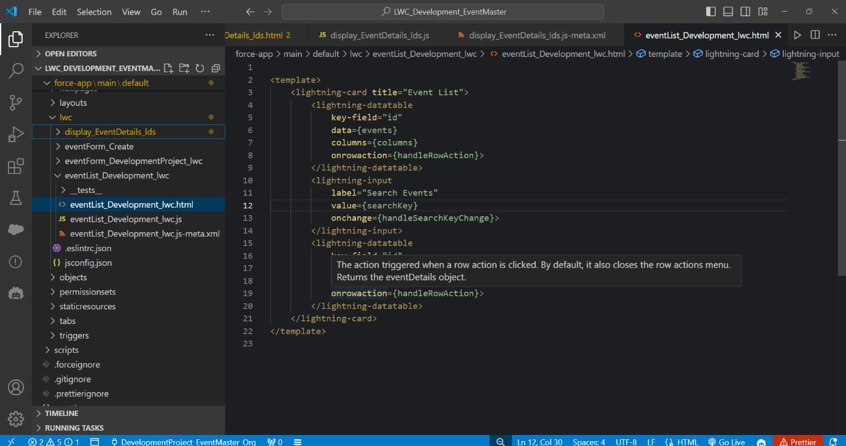the search functionality

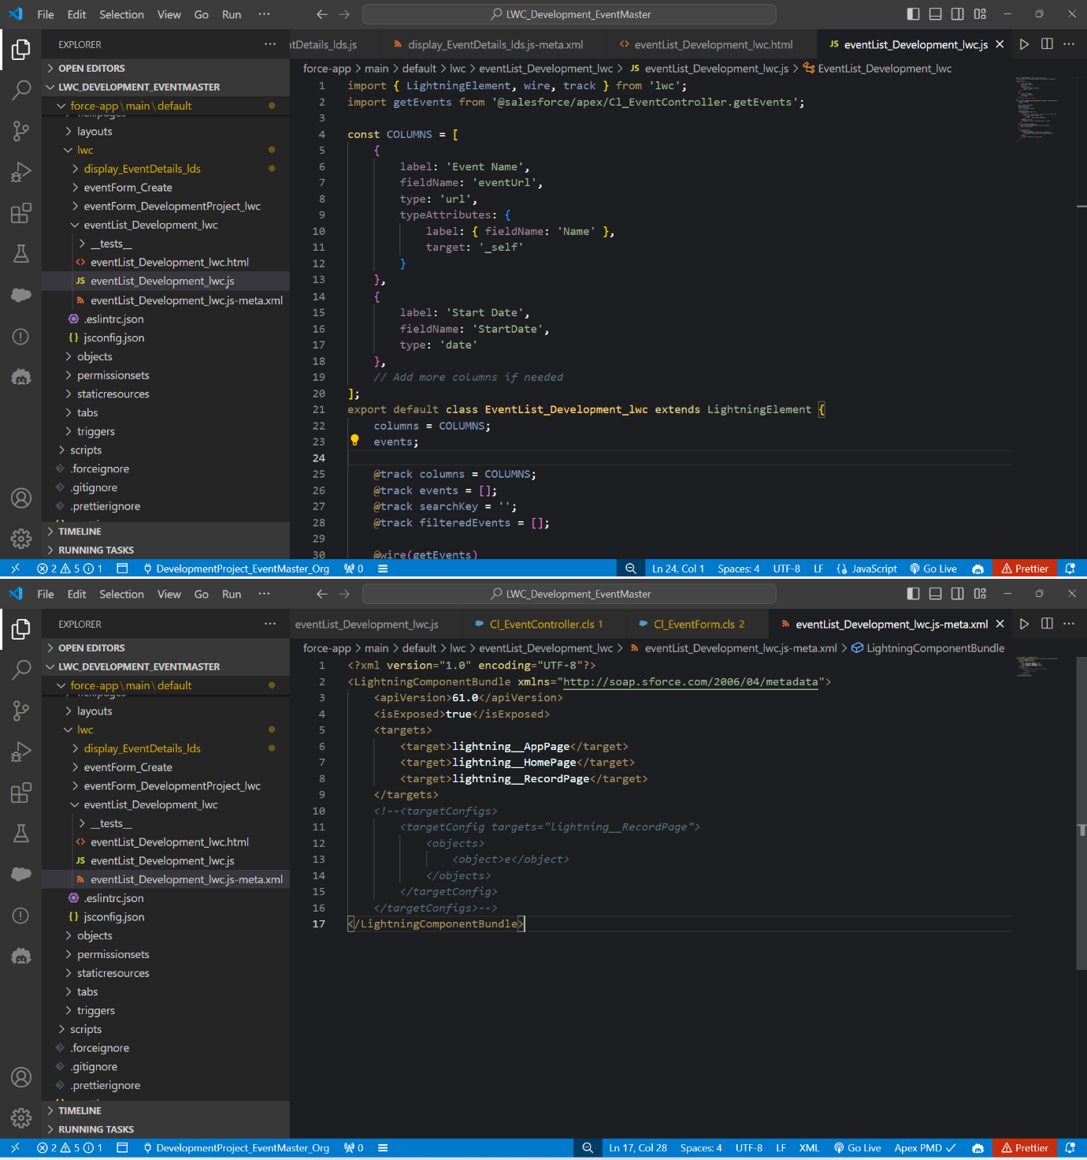

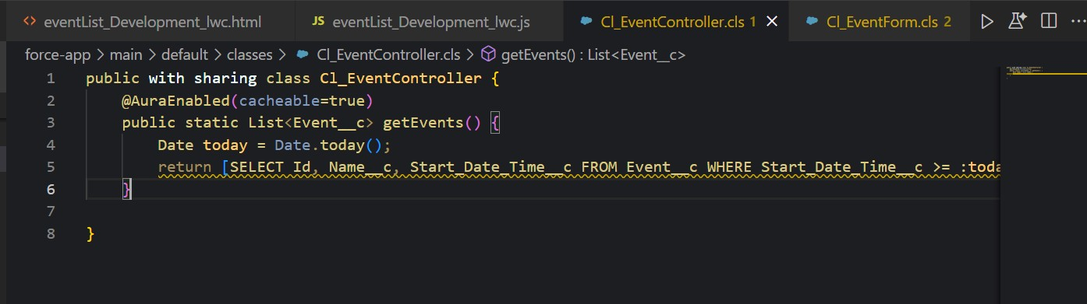

# Milestone 8

**AttendeeEvents Component:-** Develop a Lightning web component which will sit

inside the detail page of the Attendee object and display the details of the Event that attendee has attended or registered.

The component must have 2 sections

1. - Upcoming Events: - Display all the event that attendee has registered
2. - Past Events - Display all the Event that the user was part of.

Like the Event Detail Component & Event List Component, we will also implement in 2 part. Find the details below.

Part 1 - Implement the Upcoming Event functionality and use lightning accordion to have two separate sections Part 2 - Implement the Past Events functionality

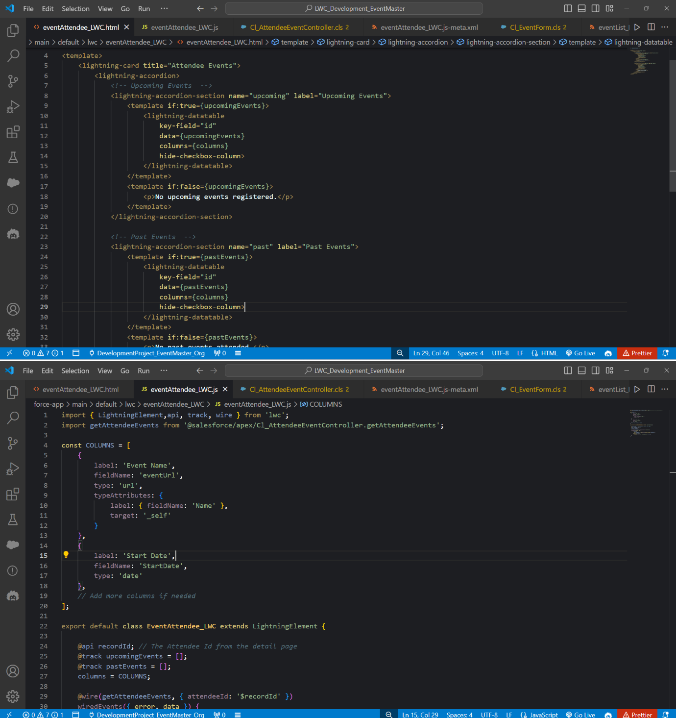

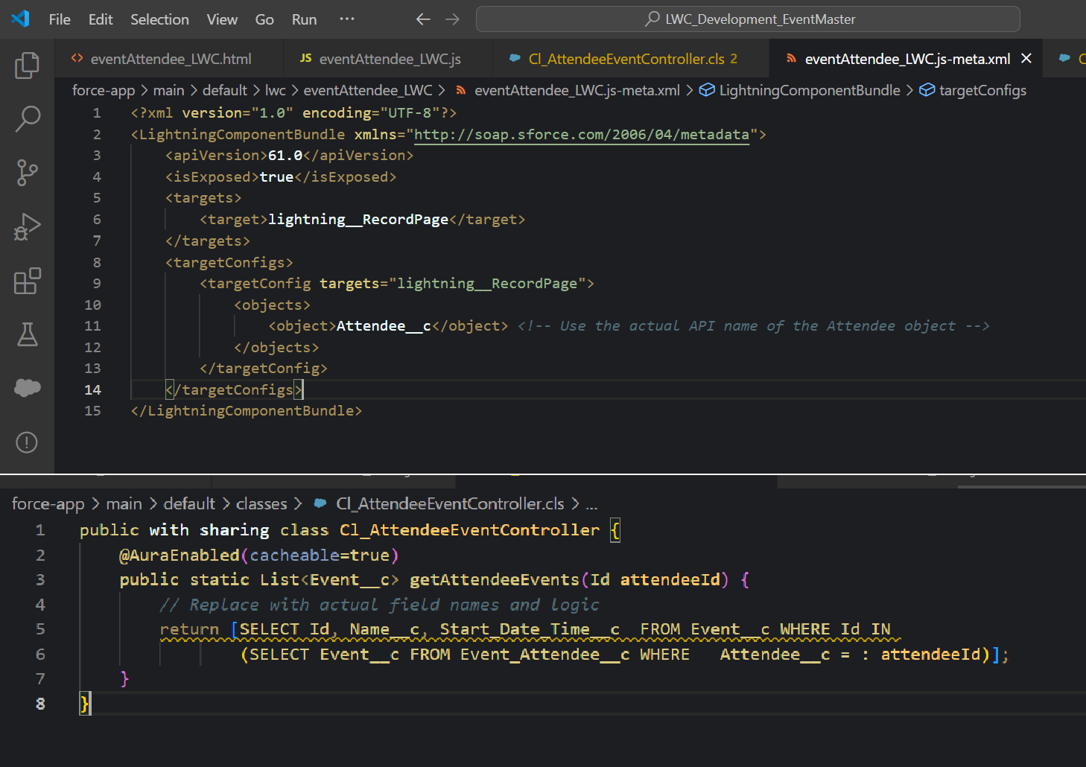

# Milestone9 -

**Modify Event Detail Component: -** Add New Speaker Button on Event Speaker Tab and New Attendee on Event Attendees Tab to associate the Speakers and attendees to an event.

**Note-** We are going to use Lightning Navigation to open the create record wizard for the same. For Example, to create the Event Speaker record we can use below code.

